
Chelsea Public Schools
Superintendent’s Office
Almi G. Abeyta, Ed.D

October 1, 2020

Dear Colleagues,

October is National Principals Month!

Principals are among the hardest working, yet often least recognized individuals in education. Principals set the academic tone for their schools and are a mobilizing force for achieving student success. 2020 has been a challenging year and our principals have been leading and serving throughout this unprecedented time. We are fortunate to have such wonderful leaders! Please help me in thanking our principals for their tireless efforts in pursuit of excellence in education! Let's shower them with appreciation this month!

Sincerely,
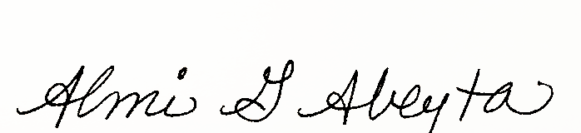

Dr. Almi G. Abeyta

